Media Contact: Kaye Communications, Inc.

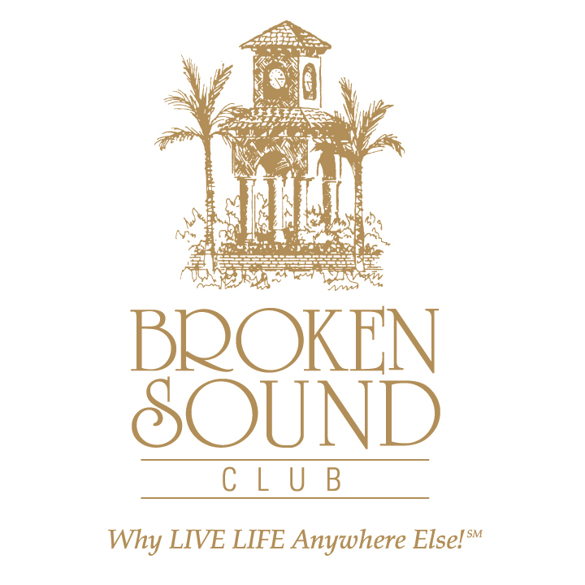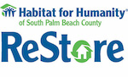
BROKEN SOUND CLUB LEADS AS “CATALYST COUNTRY CLUB”
FOR THE COMMUNITY RE-STORE CLUB CHALLENGE
A New Regional Habitat For Humanity of South Palm Beach County Initiative

Challenge Kicks Off to Raise Awareness of and “Stock Up” Nonprofit’s
Home Improvement Center and Thrift Shop ReStores

Keeping in line with its sustainability mission of building healthy communities and as the largest private club donor of homes to Habitat for Humanity of South Palm Beach County’s (HFHSPBC) homes,
Broken Sound Club launched the Community Re-Store Club Challenge (CRCC), new regional HFHSPBC initiative. Serving as the “catalyst country club community”, BSC conceived and kicked off the inaugural communitywide CRCC Day to increase awareness of and grow much-needed donation inventory at the nonprofit’s home improvement center thrift shop ReStores in Boca Raton and Delray.

Beginning ‘at home’ this week with BSC’s 1,618 residences throughout its 27 neighborhoods, the 5-Star Platinum Club of America issued the challenge inviting and encouraging fellow private clubs and communities in South Palm Beach County to follow suit by activating their own CRCC club and community/resident efforts. Demonstrating once again BSC’s trailblazing dedication to sustainability, club members donated excess new and gently used household items to support local families, while reducing landfill waste. According to HFHSPC leadership, the nonprofit itself has diverted over 1112 tons of material from landfills since 2005.

In addition to a truck full of household donations, which included artwork, lamps, oriental rugs, dining room suites and even a stainless steel kitchen stove, the CRCC’s opening ceremonies included presentation of a cash donation of $179,750 to build two new homes. In turn, HFHSPBC presented Broken Sound Club with meaningful and beautifully framed crayon art pictures of the two new homes drawn by the Habitat children who will live in them. “When you hold these crayon drawings in your hands, you realize you are holding an entire family’s life dream being realized.” said Kari Oeltjen, HFHSPC Chief Development Officer.

“We at Broken Sound Club are so proud to continue our tradition and community legacy by kicking off this community challenge and supporting the construction of two new Habitat homes,” noted BSC GM and Chief Operating Officer John Crean, CCE. “Our more than 2800 members residing in our Club’s 27 neighborhoods applaud the work and strides achieved by Habitat for Humanity in South Palm Beach County and are honored to be part of its growth. It is our vision that more private clubs and community homeowners associations take the competitive collective challenge of stocking up the ReStores and expanding Habitat neighborhoods.”

HFHSPBC CEO and President Randy Nobles shared that proceeds from the nonprofit’s ReStores fund the permitting and construction operations that deliver affordable homes for hard working families in our community who cannot seem to get ahead and qualify for traditional bank mortgages by offering sweat equity programs and interest free mortgages to break the poverty cycle and change the trajectory of entire families for generations. Proceeds also support increased programming and education scholarships for children of homeowners to restore hope by breaking challenging economic cycles.

Inventory at the ReStores, shopped by the general public and designers, feature not just gentle items from individuals, but also new designer furniture, accessories and artwork retailers and housing supply manufacturers (including hurricane shutters) from warehouse overstocks and floor models to make room for new incoming merchandise.

“HFHSPC is always a hand-up, never a hand-out,” added Nobles. “Support of our mission strengthens our community and is one of the greatest social impacts one can make through their donations to or buying from our ReStores, sponsoring the construction of new homes, and participating in one of our volunteer home builds.”
`
Joining Nobles, Crean and Broken Sound Club Board Member Lee Edelstein for the first-ever CRCC Day were City Council Member Robert Weinroth, Boca Raton Federation of Homeowners Association Board Member Gene Folden, HFHSPBC Chief Development Officer Kari Oeltjen, HFHSPBC Chairman Rick Howard and past chair Scott Sullivan with board members Eric Lebersfeld who is also a BSC resident and Eric Bucher.

For more information on HFHSPBC and its ReStores, visit www.habitatsouthpalmbeach.org. To join the CCRC, contact Kari Oeltjen at (561) 819-6070 or koeltjen@hfhboca.org.

For more information on Broken Sound Club, its residential villages, and club membership program, visit BrokenSoundClub.org, or contact Director of Membership Maureen Schreiber at (561) 241-6820 or Maureen_Shreiber@BrokenSoundClub.org.

About Broken Sound Club:
Whatever one’s passion or interest…their active enviable home life, business life, sporting life, and social life complement each other perfectly at Broken Sound Club. Known as the “friendly” club for its signature blend of warmth, elegance and genuine hospitality, this award-winning private gated golf and country club community offers a choice of 27 lushly landscaped intimate residential villages, each with its own character. All are just minutes away from its main clubhouse with indoor and outdoor dining, two Audubon Sanctuary certified signature golf courses (one host to the PGA Champions Tour season opener for 11 consecutive years), a new two-acre $6 million poolscape with bistro, a new $7 million 35,000-square-foot spa and fitness center, and 23 tennis courts. This 5-Star Platinum Club of America is conveniently close to two international airports, and just a few miles from the private Boca Raton Executive Airport, Boca’s burgeoning Class A office parks and vibrant Downtown, pristine beaches, A-rated public and award-winning private schools, two universities, sports arenas and stadiums, and an exciting world of shopping, dining, art and culture, recreation, and nightlife.
About Habitat For Humanity Of South Palm Beach County:

Habitat For Humanity of South Palm Beach County that brings people together to build homes, community and hope is a nonprofit, 501(c)(3) organization that works to provide affordable homeownership opportunities for hardworking and deserving families in the cities of Boynton Beach, Delray Beach, and Boca Raton, Florida. The nonprofit depends upon volunteer labor and tax-deductible donations of money, materials, services and property to fulfill its mission.

